SIMATS ENGINEERING
ASSESSMENT TOOL 3 - Output Prediction

COURSE NAME: Data Structures COURSE CODE: CSA03
Register Number | 192424245
Name | g.vinay kumar reddy
Assessment Tool Weightage: 35%

COURSE OUTCOME COVERED

CO1: Apply suitable data structures and ADTs for efficient problem solving by analyzing time and space complexity. (BL3, BL4)

Questions: 5 | EACH QUESTIONS CARRIES: 5 MARKS Total Marks: 25 Duration: ONE HOUR

S. No. | List of Questions
1 | 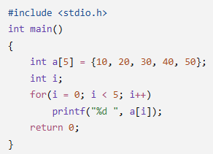  Array Traversal  Program
2 | 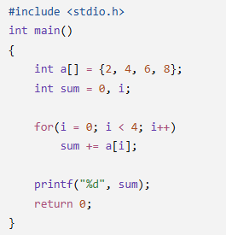  Sum of Array Elements  Program
3 | 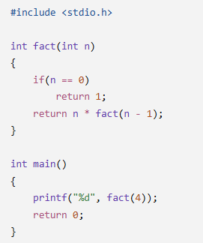  Recursive Factorial  Program
4 | 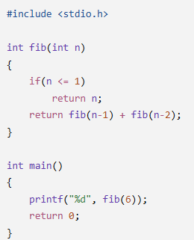  Recursive Fibonacci  Program
5 | 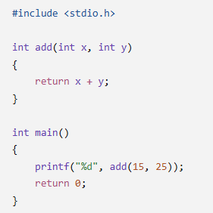  Function as ADT Operation  Program

Code of Conduct:

I ____________________ (Name / Reg No) certify that this submission is my original work and that I have adhered to the guidelines specified for this assessment.
I understand that any violation of academic integrity rules will result in disciplinary action.

Signature of the student:

Q1. Array Traversal Program
Program:
#include <stdio.h>
int main()
{
int a[5] = {10, 20, 30, 40, 50};
int i;
for(i = 0; i < 5; i++)
printf("%d ", a[i]);
return 0;
}

Program Logic:
The program initializes an integer array containing five elements. The for loop starts from index 0 and continues while i < 5. During each iteration, a[i] accesses and prints the corresponding array element. The loop terminates when i becomes 5.
Variable Tracing:
Iteration | i | a[i] | Printed Value
1 | 0 | 10 | 10
2 | 1 | 20 | 20
3 | 2 | 30 | 30
4 | 3 | 40 | 40
5 | 4 | 50 | 50
When i becomes 5, the condition i < 5 becomes false, and the loop terminates.
Output:
10 20 30 40 50
Time and Space Complexity:
Time complexity is \(O(n)\), because every array element is visited once. Auxiliary space complexity is \(O(1)\), because only a constant amount of extra space is used.

Q2. Sum of Array Elements
Program:
#include <stdio.h>
int main()
{
int a[] = {2, 4, 6, 8};
int sum = 0, i;

for(i = 0; i < 4; i++)
sum += a[i];

printf("%d", sum);
return 0;
}
Program Logic:
The program calculates the sum of all elements in an integer array. Initially, sum is assigned 0. The for loop visits each element and adds it to sum using the += operator. After processing all four elements, the final sum is printed.
Variable Tracing:
Iteration | i | a[i] | Calculation | sum
1 | 0 | 2 | \(0+2\) | 2
2 | 1 | 4 | \(2+4\) | 6
3 | 2 | 6 | \(6+6\) | 12
4 | 3 | 8 | \(12+8\) | 20
When i becomes 4, the condition i < 4 becomes false, and the loop terminates.
Output:
\[ \text{sum}=2+4+6+8=20 \]
20
Time and Space Complexity:
Time complexity is \(O(n)\), because each array element is processed once. Auxiliary space complexity is \(O(1)\), because only the variables sum and i are used as extra variables.

Q3. Recursive Factorial Program
Program:
#include <stdio.h>

int fact(int n)
{
if(n == 0)
return 1;

return n * fact(n - 1);
}

int main()
{
printf("%d", fact(4));
return 0;
}
Program Logic:
The program calculates the factorial of 4 using recursion. The factorial of a number is the product of all positive integers up to that number. The recursive formula is
\[ n!=n\times(n-1)! \]
The base condition n == 0 returns 1 and stops further recursive calls. Otherwise, the function calls itself with n - 1 and multiplies the result by n.
Function Call Tracing:
The recursive calls are
\[ fact(4)=4\times fact(3) \]
\[ fact(3)=3\times fact(2) \]
\[ fact(2)=2\times fact(1) \]
\[ fact(1)=1\times fact(0) \]
\[ fact(0)=1 \]
The results return in reverse order.
Function Call | Calculation | Return Value
fact(0) | Base condition | 1
fact(1) | \(1\times1\) | 1
fact(2) | \(2\times1\) | 2
fact(3) | \(3\times2\) | 6
fact(4) | \(4\times6\) | 24
Output:
\[ 4!=4\times3\times2\times1=24 \]
24
Time and Space Complexity:
Time complexity is \(O(n)\), because the function makes a linear number of recursive calls. Auxiliary space complexity is \(O(n)\), because the recursive calls occupy the call stack until the base condition is reached.

Q4. Recursive Fibonacci Program
Program:
#include <stdio.h>

int fib(int n)
{
if(n <= 1)
return n;

return fib(n - 1) + fib(n - 2);
}

int main()
{
printf("%d", fib(6));
return 0;
}
Program Logic:
The program calculates the sixth Fibonacci number using recursion. In the Fibonacci sequence, each number after the first two is the sum of the previous two numbers. The base conditions are fib(0) = 0 and fib(1) = 1. For other values, the function calculates fib(n - 1) + fib(n - 2).
The recursive formula is
\[ F(n)=F(n-1)+F(n-2) \]
Function Call Tracing:
\(n\) | Calculation | \(F(n)\)
0 | Base condition | 0
1 | Base condition | 1
2 | \(F(1)+F(0)=1+0\) | 1
3 | \(F(2)+F(1)=1+1\) | 2
4 | \(F(3)+F(2)=2+1\) | 3
5 | \(F(4)+F(3)=3+2\) | 5
6 | \(F(5)+F(4)=5+3\) | 8
Therefore,
\[ fib(6)=fib(5)+fib(4)=5+3=8 \]
Output:
8
Time and Space Complexity:
Time complexity is \(O(2^n)\), because the simple recursive implementation repeatedly recalculates Fibonacci values. Auxiliary space complexity is \(O(n)\), because the maximum depth of the recursive call stack is proportional to \(n\).

Q5. Function as an ADT Operation
Program:
#include <stdio.h>

int add(int x, int y)
{
return x + y;
}

int main()
{
printf("%d", add(15, 25));
return 0;
}
Program Logic:
The program defines an add() function that accepts two integer parameters, x and y. It adds these values and returns the result. The main() function calls add(15, 25) and prints the returned value. This demonstrates an operation encapsulated behind a function interface, although the code is not a complete ADT implementation.
Function Call Tracing:
Step | Operation | Result
1 | Call add(15, 25) | Arguments passed
2 | Assign parameters | x = 15, y = 25
3 | Evaluate x + y | \(15+25=40\)
4 | Return result | 40
5 | Execute printf() | Prints 40
The function returns 40 to the calling statement, and printf() displays that value.
Output:
\[ add(15,25)=15+25=40 \]
40
Time and Space Complexity:
Time complexity is \(O(1)\), because the function performs one addition operation regardless of the input values. Auxiliary space complexity is \(O(1)\), because it uses a constant amount of extra space and does not involve recursion.

RUBRICS FOR CALCULATION:

Criteria | Weightage (5 Marks) | Level 4 – Exemplary (5 Marks) | Level 3 – Proficient (4 Marks) | Level 2 – Developing (3 Marks) | Level 1 – Beginning (1–2 Marks)
Understanding of Program Logic | 1 | Correctly identifies the complete program flow and execution sequence. | Minor misunderstanding of program flow. | Partial understanding of logic. | Unable to interpret the program logic.
Trace of Variables / Function Calls | 1 | Accurately traces all variable values, iterations, and recursive calls. | Traces most values correctly with minor errors. | Traces some values but misses important steps. | Incorrect or no tracing.
Output Prediction Accuracy | 2 | Output predicted completely and correctly. | Output mostly correct with minor mistakes. | Output partially correct. | Output incorrect or missing.
Complexity Interpretation (Time/Space) | 1 | Correctly identifies and justifies complexity where applicable. | Correct complexity with limited justification. | Partial understanding of complexity. | Incorrect or no complexity analysis.

